Database System Engineering and Distributed Backend Development

JOINS AND SET OPERATIONS

Name: M.Akhila
Roll No: 2520030511

Section: 7

Step 1 — Create and Select a Database
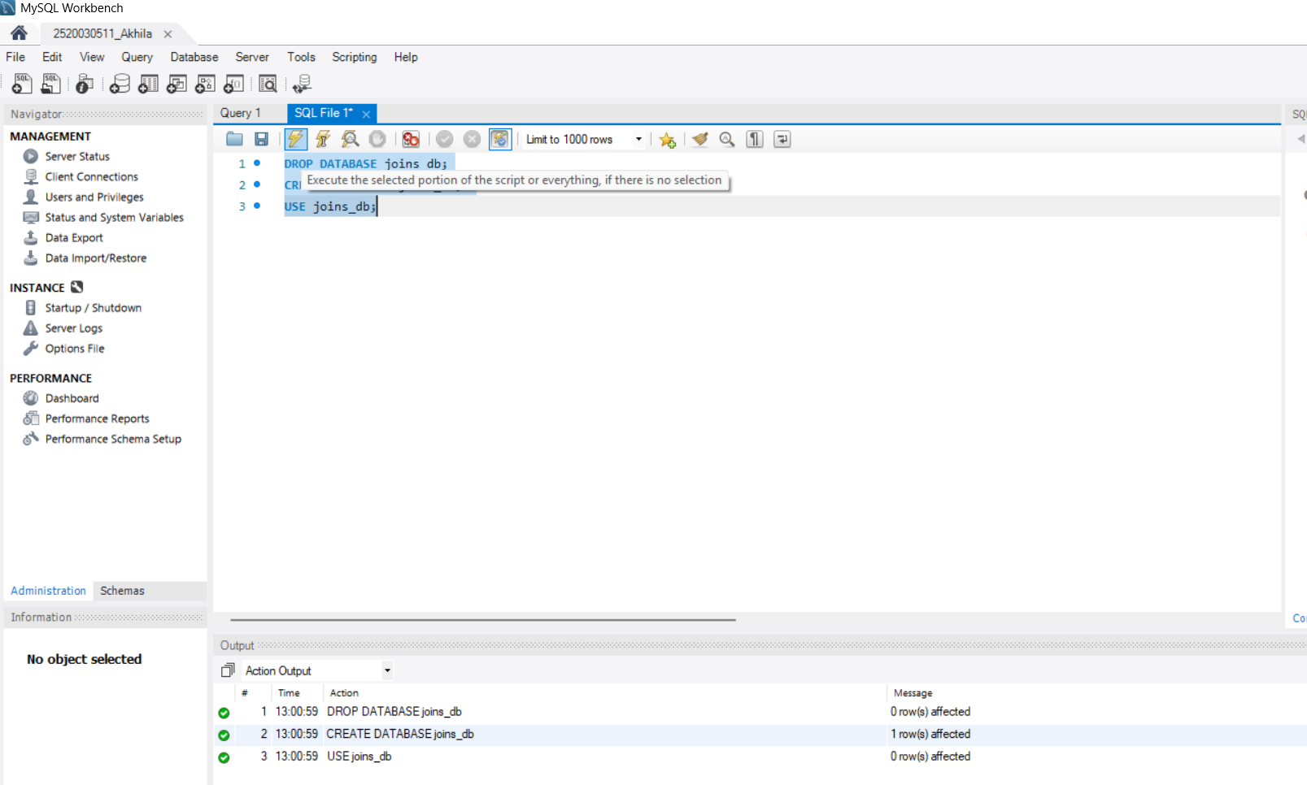Query:
CREATE DATABASE joins_db; USE joins_db;

Step 2 — Create the Tables (class, class_info)
Query:
CREATE TABLE class (
id INT,
name VARCHAR(30)
);

CREATE TABLE class_info ( id INT,
address VARCHAR(30)
);

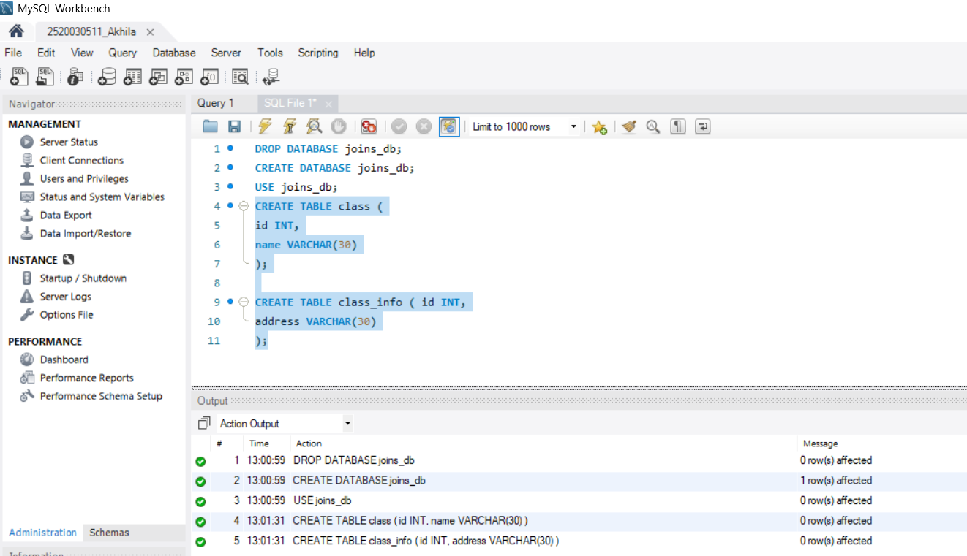

Step 3 — Insert Data
Query:
INSERT INTO class VALUES
(1,'Sathwika'),
(2,'Akhila'),
(4,'Srihitha');

INSERT INTO class_info VALUES (1,'DELHI'),
(2,'MUMBAI'),
(3,'CHENNAI');

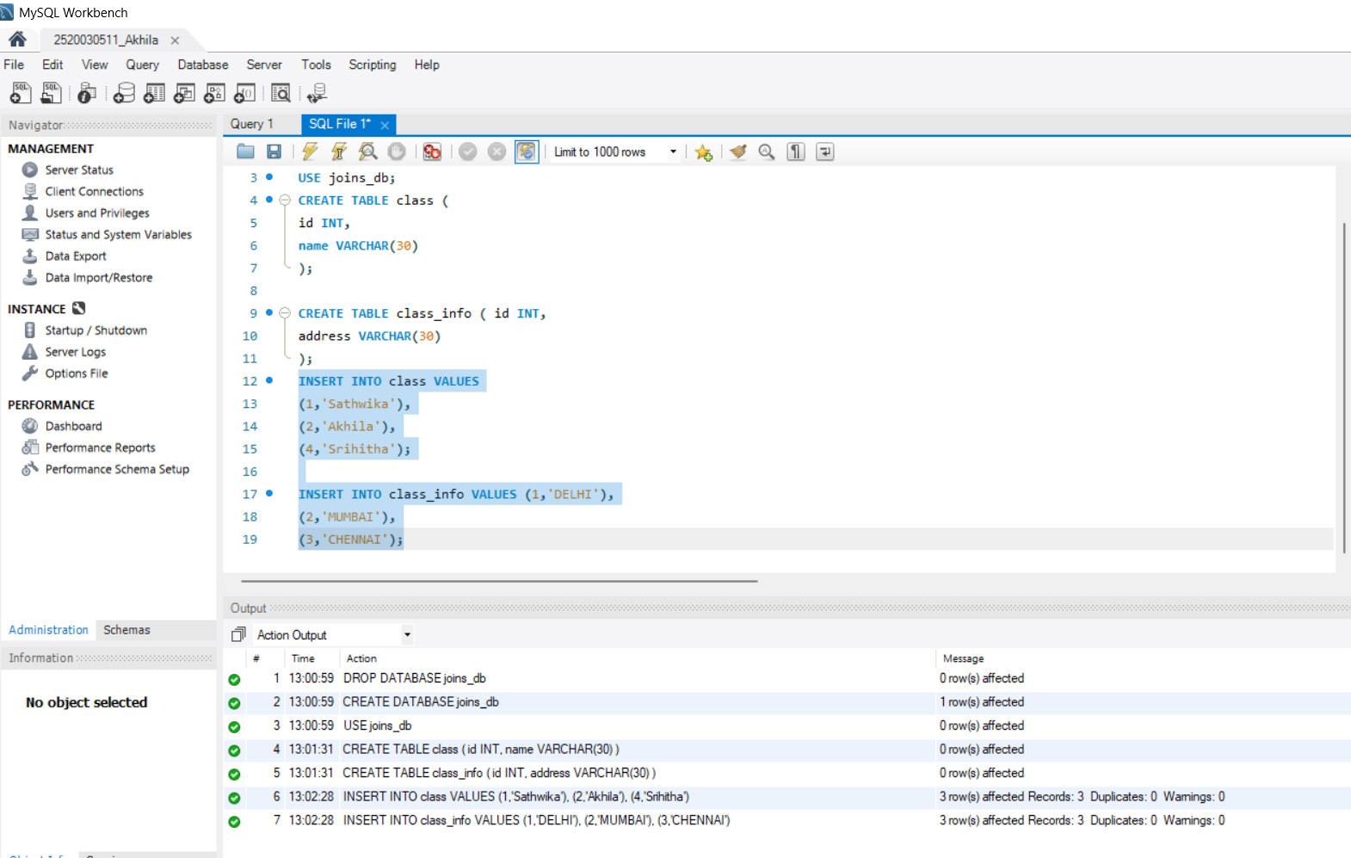

Step 4 — Question 1: CROSS JOIN
Query:
SELECT *
FROM class
CROSS JOIN class_info;
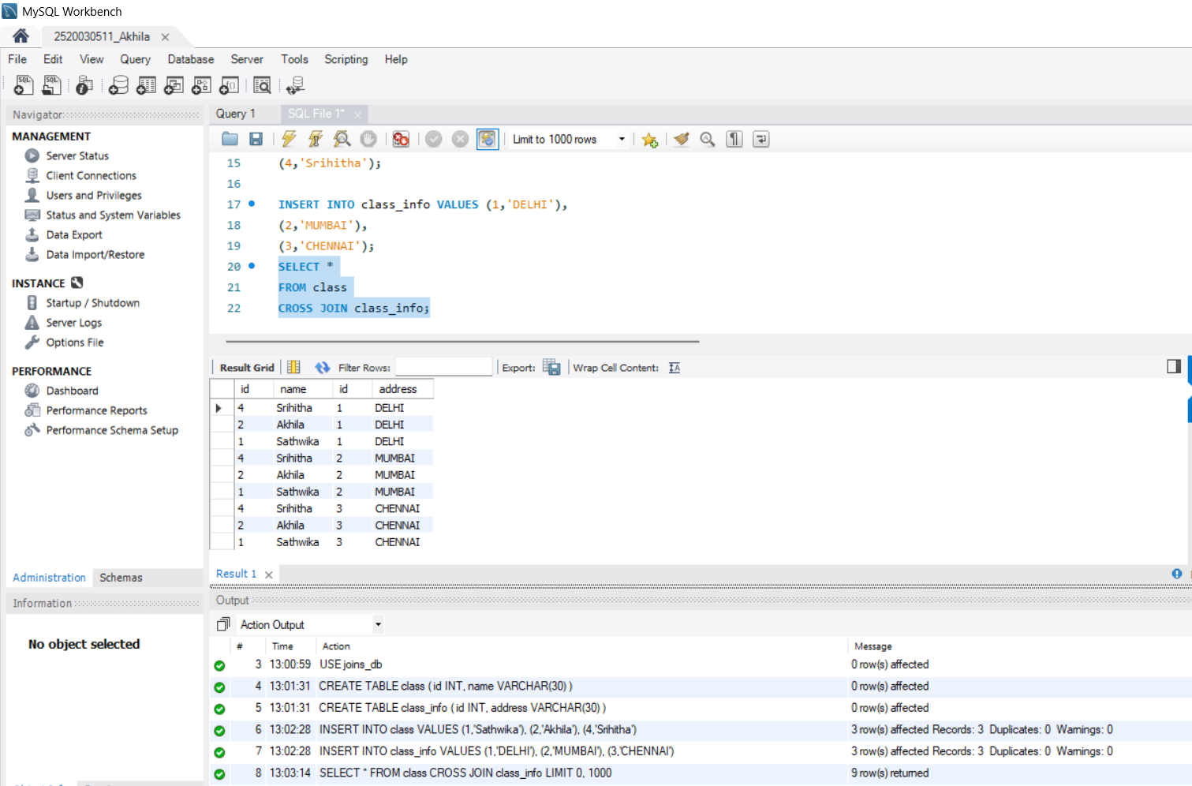

Step 5 — Recreate Tables for INNER JOIN Section
Query:
DROP TABLE class, class_info;

CREATE TABLE class (
id INT,
name VARCHAR(30)
);

CREATE TABLE class_info ( id INT,
address VARCHAR(30)
);

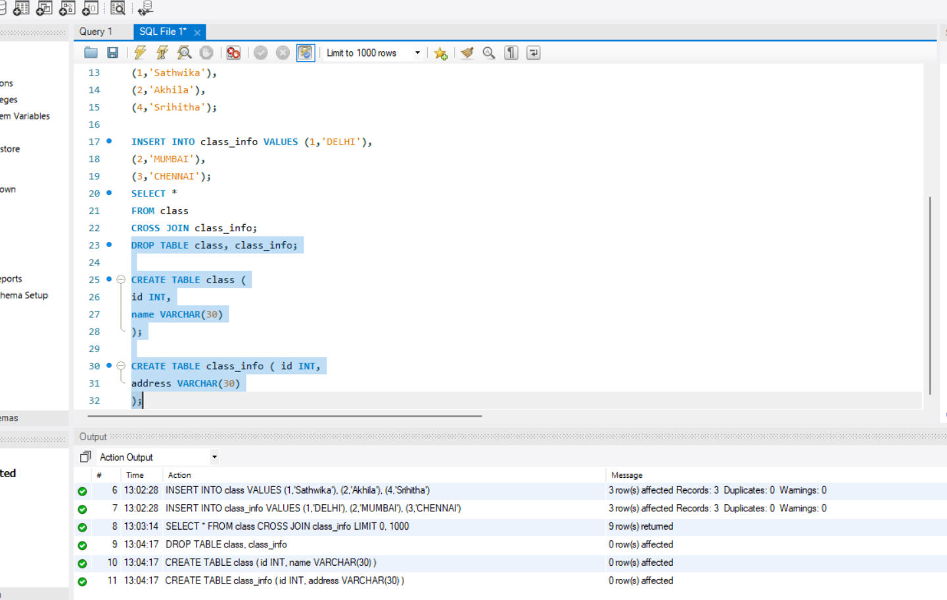

Step 6 — Insert Updated Data
Query:
INSERT INTO class VALUES
(1,'Sathwika'),
(2,'Nikki'),
(3,'Akhila'),
(4,'Srihitha');

INSERT INTO class_info VALUES (1,'DELHI'),
(2,'MUMBAI'),
(3,'CHENNAI');

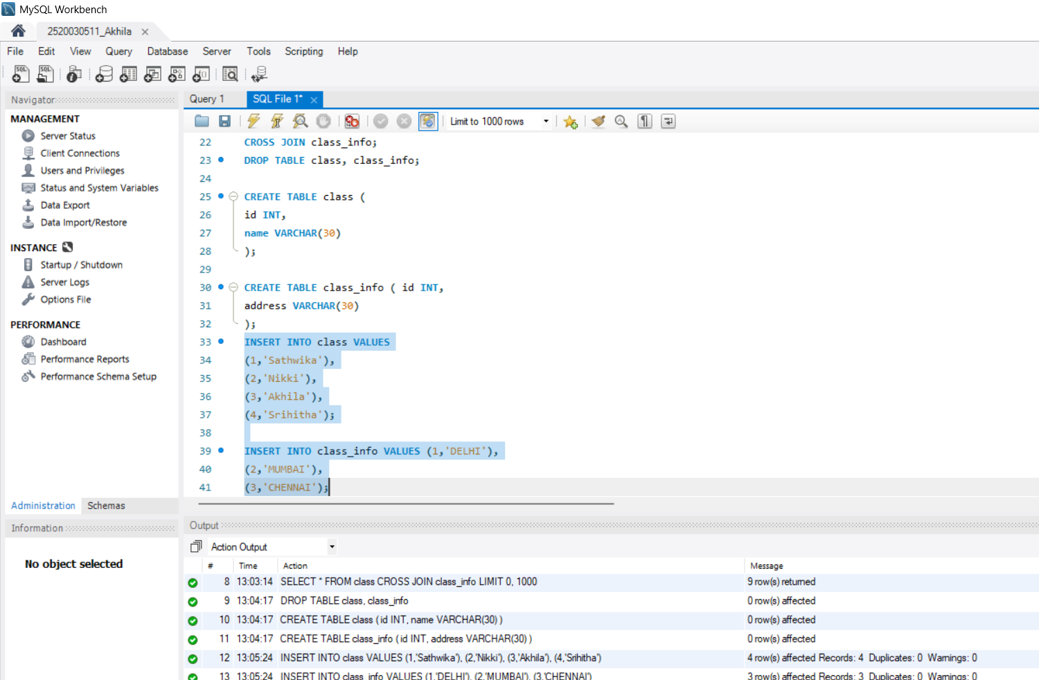

Step 7 — Question 2: INNER JOIN
Query:
SELECT *
FROM class
INNER JOIN class_info
ON class.id = class_info.id;

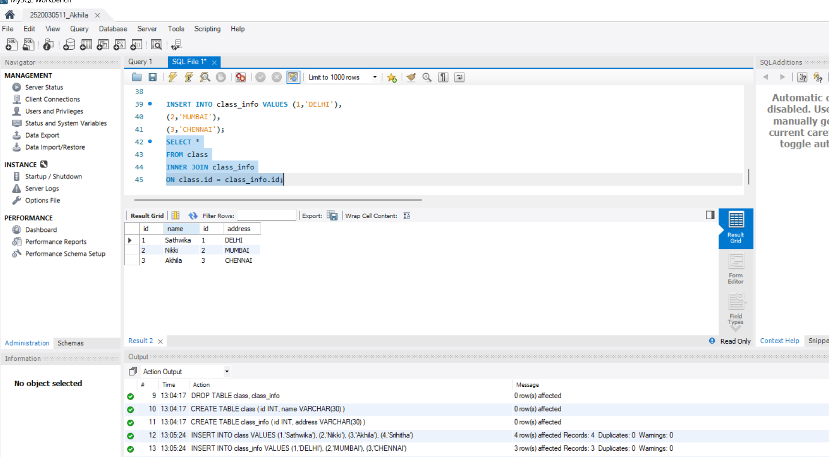

Step 8 — Question 3: INNER JOIN (Selected Columns)
Query:
SELECT class.name,
class_info.address FROM class
INNER JOIN class_info
ON class.id = class_info.id;
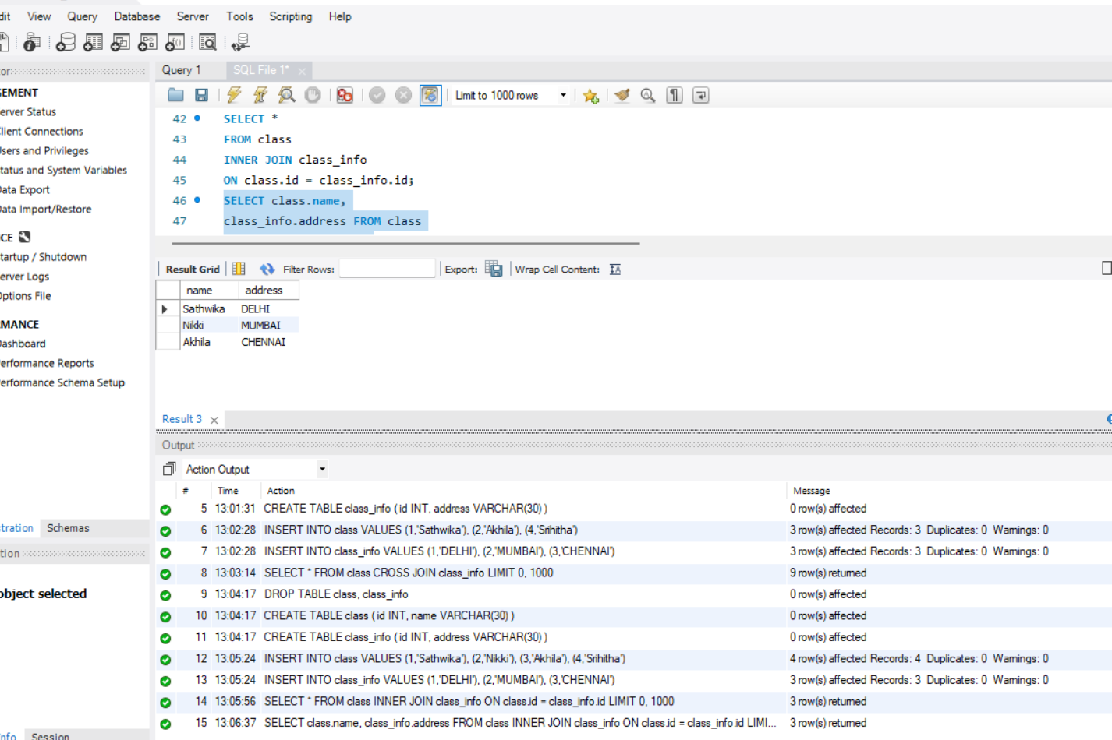

Step 9 — Question 4: NATURAL JOIN
Query:
SELECT *
FROM class
NATURAL JOIN class_info;

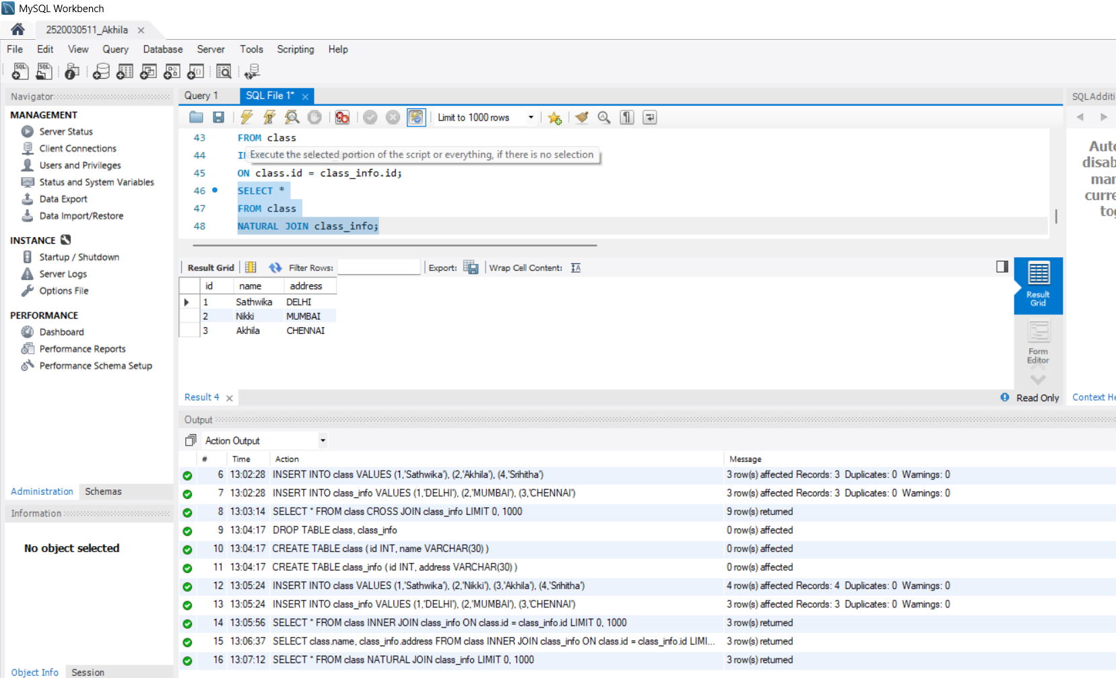

Step 10 — Insert Extra Rows for Outer Join Section
Query:
INSERT INTO class VALUES
(5,'Rohan');

INSERT INTO class_info VALUES (7,'NOIDA'),
(8,'PANIPAT');



Step 11 — Question 5: LEFT OUTER JOIN
Query:
SELECT *
FROM class
LEFT OUTER JOIN class_info ON class.id = class_info.id;

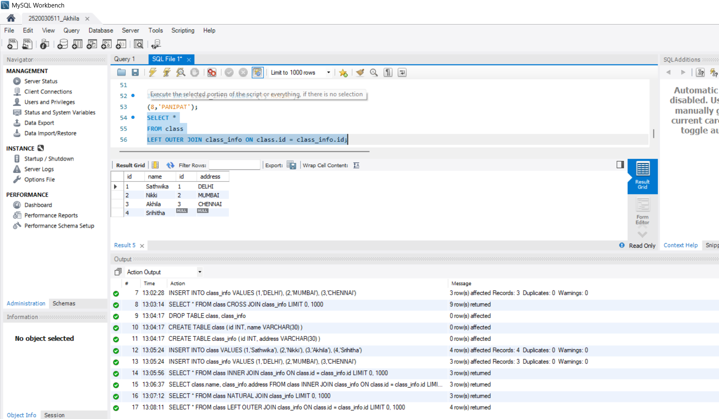

Step 12 — Question 6: LEFT JOIN (Unmatched Only)
Query:
SELECT *
FROM class
LEFT JOIN class_info
ON class.id = class_info.id WHERE class_info.id IS NULL;

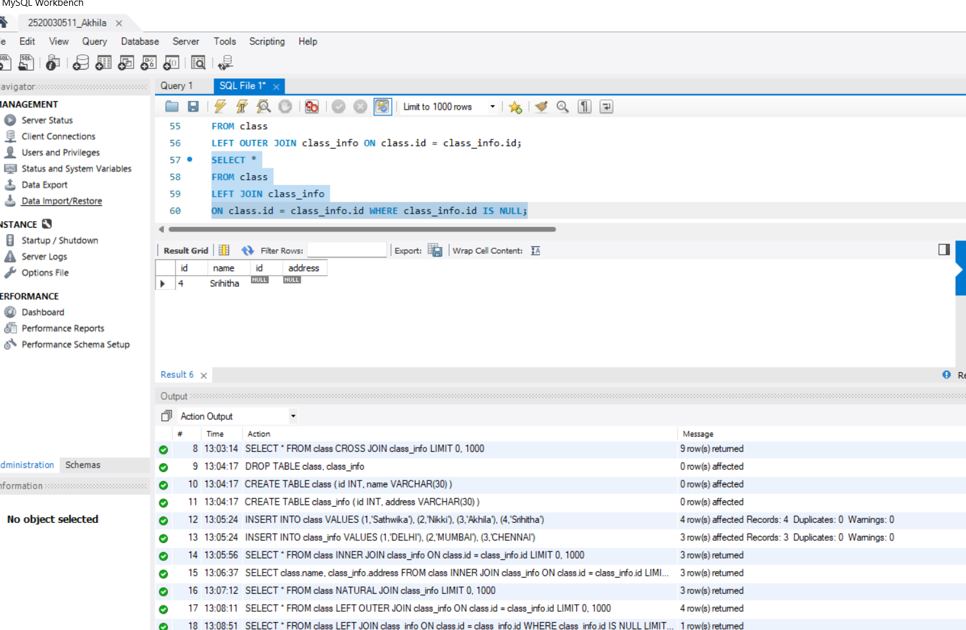

Step 13 — Question 7: RIGHT OUTER JOIN
Query:
SELECT *
FROM class
RIGHT OUTER JOIN class_info ON class.id = class_info.id;

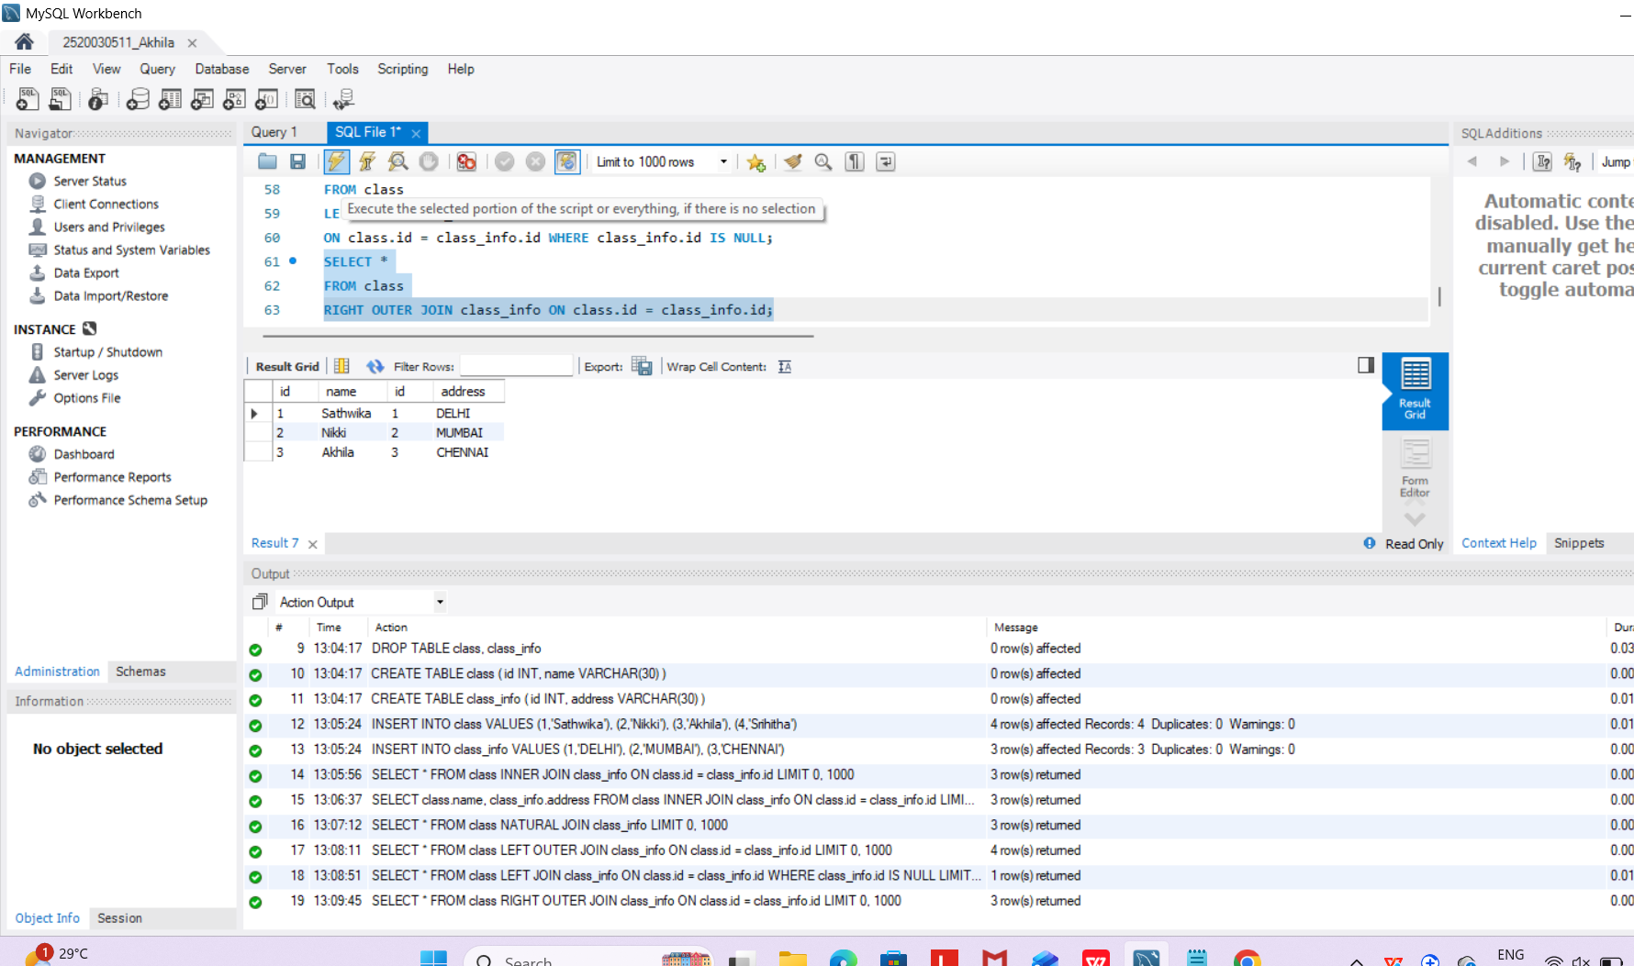

Step 14 — Question 8: RIGHT JOIN (Unmatched Only)
Query:
SELECT *
FROM class
RIGHT JOIN class_info
ON class.id = class_info.id WHERE class.id IS NULL;


Step 15 — Question 9: FULL OUTER JOIN
Query:
SELECT *
FROM class
LEFT JOIN class_info
ON class.id = class_info.id UNION
SELECT *
FROM class
RIGHT JOIN class_info
ON class.id = class_info.id;

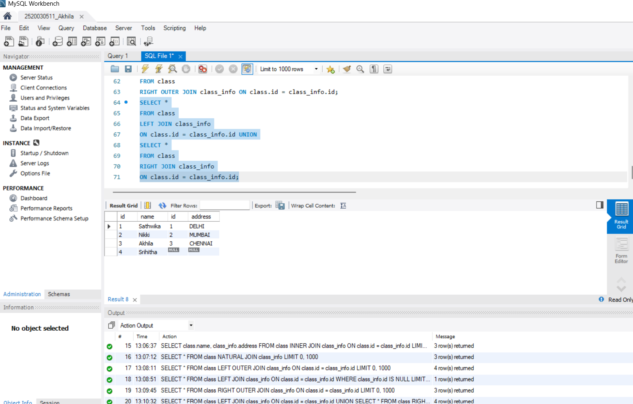
Step 16 — Question 10: FULL OUTER JOIN (Unmatched Only)
Query:
SELECT *
FROM class
LEFT JOIN class_info
ON class.id = class_info.id WHERE class_info.id IS NULL UNION
SELECT *
FROM class
RIGHT JOIN class_info
ON class.id = class_info.id WHERE class.id IS NULL;

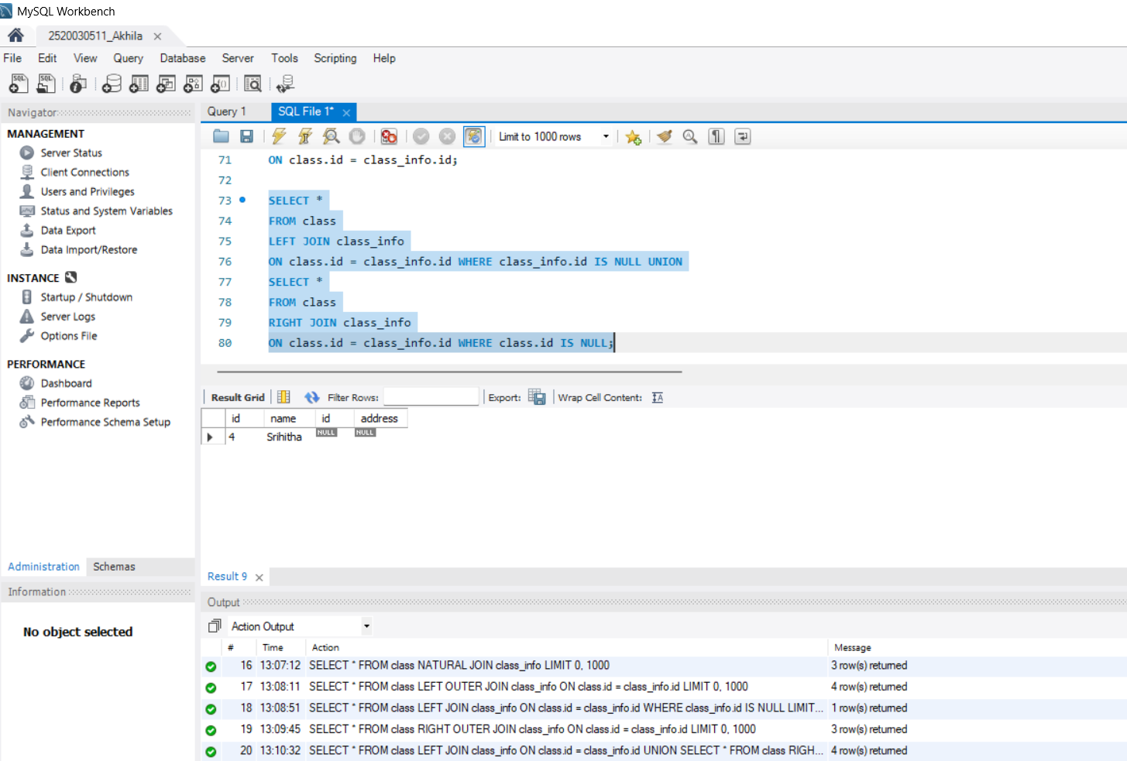
Step 17 — Create first_table and second_table (for UNION section)
Query:
CREATE TABLE first_table( id INT,
name VARCHAR(30)
);

CREATE TABLE second_table( id INT,
name VARCHAR(30)
);

INSERT INTO first_table VALUES (1,'Hansika'),
(2,'Hasini');

INSERT INTO second_table VALUES (2,'Hasini'),
(3,'Rohan');

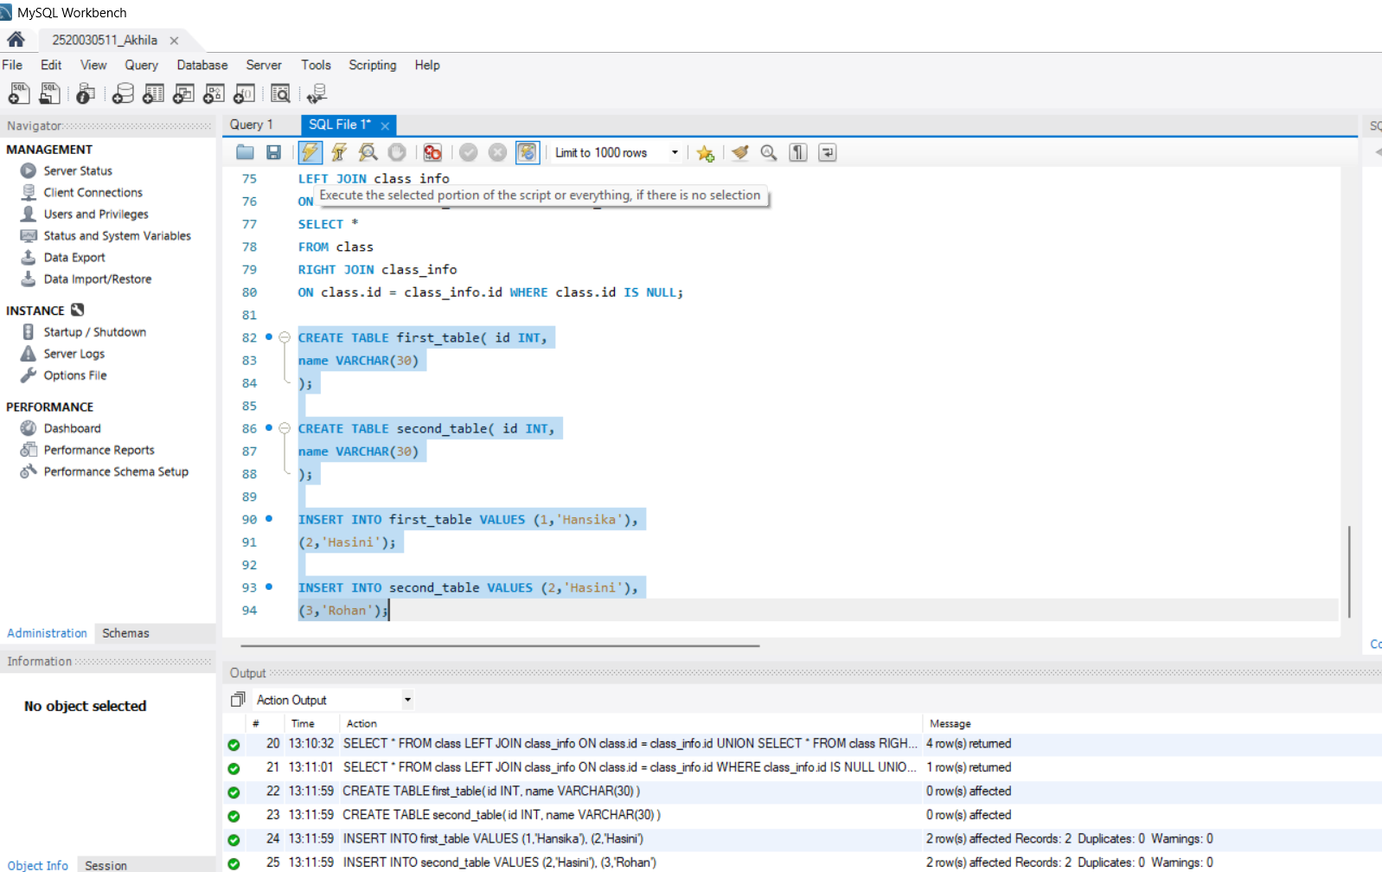

Step 18 — Question 11: UNION
Query:
SELECT * FROM first_table UNION
SELECT * FROM second_table;
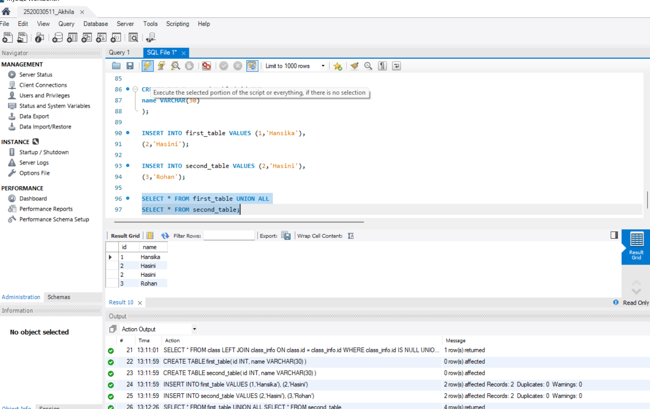

Step 19 — Question 13: UNION ALL
Query:
SELECT * FROM first_table UNION ALL
SELECT * FROM second_table;

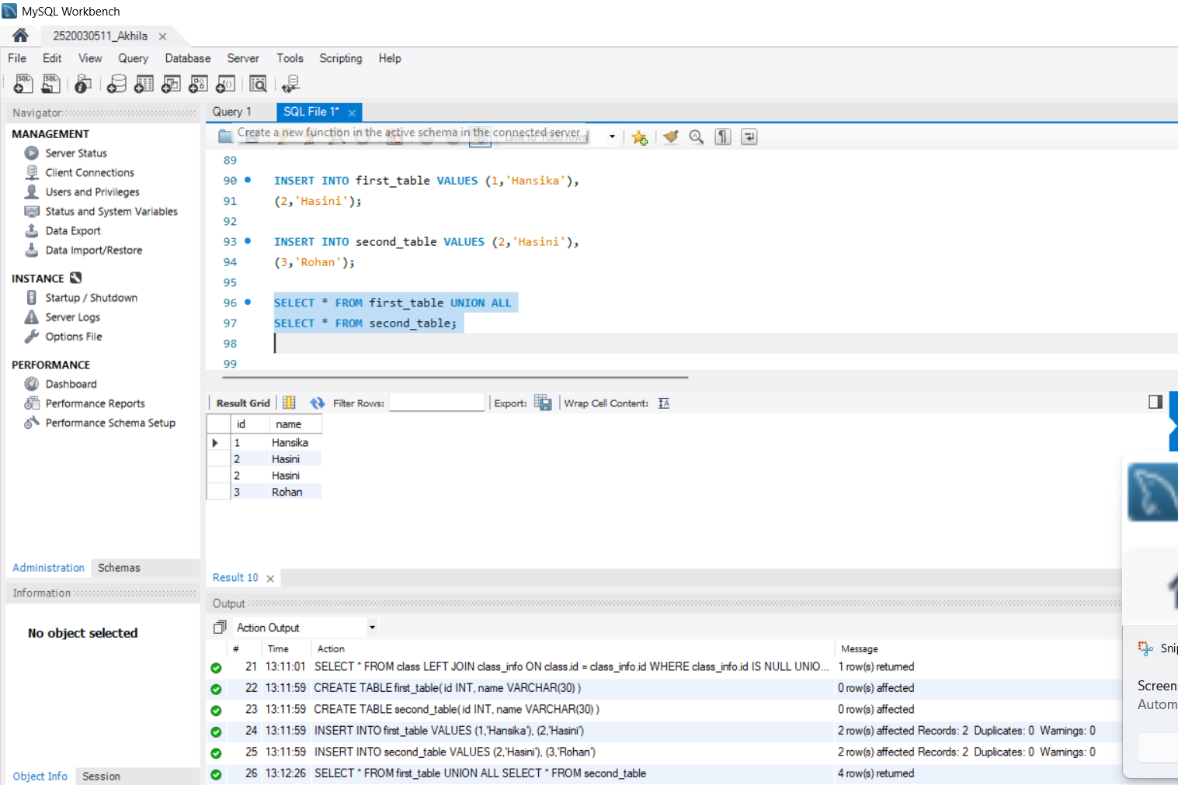

Step 21 — Question 14: UNION ALL (Row Count)


